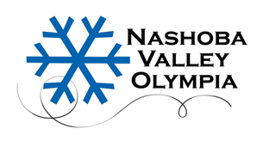

NVO SPRING ICE 2019

WELCOME to Spring Ice at Nashoba Valley Olympia.

For the 2019 season, Spring Ice will run from April 2rd through June 20th

Note: No ice on Thursday, May 16 due to the Colonial Open.

There are two sessions each evening at 5:45-6:40 pm and 6:50-7:45 pm.

TUESDAY | TUESDAY | WEDNESDAY | WEDNESDAY | THURSDAY | THURSDAY
RINK 1  5:45-6:40 pm | RINK 1 6:50-7:45 pm | RINK 1  5:45-6:40 pm | RINK 1 6:50-7:45 pm | RINK 1  5:45-6:40 pm | RINK 1 6:50-7:45 pm

The rate is $18.00 per session or $13.00 per session with an NVO prepaid card, which is $130.00 for 10 sessions. These cards are reloadable, do not expire, and may be used for NVO Spring Ice, NVO Freestyle, and NVO Summer Skate. Payments are made by cash or check. Please note: NVO does not take credit cards.

All sessions are on a first come/first serve basis.

If you have any questions, please call Lynne Quinn in the NVO office at 978-263-3020.

NASHOBA VALLEY OLYMPIA, INC.
P. O. Box 793
Acton, MA 01720-0793
978-263-3020

Fax 978-263-5831
Website: www.skatenashoba.com
E-mail: nvo3@verizon.net

